The Welding Technology Influence
on the double T girder beams buckling
Lecturer Eng. Ioan-Sorin LEOVEANU, PhD¹, Assoc. Prof. Eng. Eva Kormaníková PhD²,
Assis. Eng. Kamila Kotrasová PhD², Eng. Daniel TAUS¹

¹University „Transilvania” from Braşov
²Technical University of Košice, Civil Engineering faculty,
Institute of Structural Engineering, Department of Structural Mechanics, Košice, Slovakia.

Rezumat. In domeniul Ingineriei Civile structurile de rezistentă metalice au o deosebită importanţă în reducerea greutăţii construcţiei cu deosebire în cazul construcţiilor înalte, a podurilor şi a construcţiilor cu scop industrial. Pentru a putea micşora cât mai mult greutatea structurilor metalice acestea sunt proiectate în domeniul elasto-plastic ceea ce face ca instabilităţile locale şi cele globale să devină de o importanţă covârşitoare. De mare actualitate în prezent, dar cu precădere pentru structurile viitoare, tehnologia de sudură prin marea sa flxibilitate constituie una dintre o (Maximum 5 rânduri)

Cuvinte cheie: greutatea structurilor metalice acestea sunt proiectate. (Maximum 1 rând)

Abstract. In Civil Engineering Design, the steel’s structures had a great importance on the light structures realized used to tall buildings, bridges piles and girders. To realize a smallest loading by the own weigh of the structures components there design is made in elastic-plastic state and the global and local instability become more important. The actual trends in the building design consist in using the flexibility of the welding joints technology in almost all the steel’s buildings structures and these work try to give a way for establish an correlation between welding technology and di (Maximum 5 rânduri)

Keywords: building, design, flexibility, structures components (Maximum 1 rând)

1. Introduction
The estimation of buckling load and deflection in engineering was made the first time by Euler by using the equilibrium between the internal and external moment and the general differential ordinary equation that had his name. The approximation based on Euler equation represent an ideal buckling behavior and in practice the influence of the yield stress, cross section and residual stresses play a crucial role and generally they influence a reduction factor value [4],[6],[7]. The
The real ultimate stress is lower that Euler buckling stress and the equation (1) was get without consider the shape and dimensions of the section and the way of construction.
The estimation of buckling load and deflection in engineering was made the first time by Euler by using the equilibrium between the internal and external moment and the general differential ordinary equation that had his name. The approximation based on Euler equation represent an ideal buckling behavior and in practice the influence of the yield stress, cross section and residual stresses play a crucial role and generally they influence a reduction factor value [4],[6],[7]. The
The real ultimate stress is lower that Euler buckling stress and the equation (1) was get without consider the shape and dimensions of the section and the way of construction.
reduction factor (ϕ) is determinate based of the relative slenderness (λ).
(1)
where E is the elasticity modulus; –

the relative slenderness; L_{fl} – the buckling length; σ_{C} – the yield stress; I – the inertia momentum; A – section area
The real ultimate stress is lower that Euler buckling stress and the equation (1) was get without consider the shape and dimensions of the section and the way of construction.
The estimation of buckling load and deflection in engineering was made the first time by Euler by using the equilibrium between the internal and external moment and the general differential ordinary equation that had his name. The approximation cross section and residual stresses play a crucial role and generally they influence a reduction factor value [6],[4],[7]. The

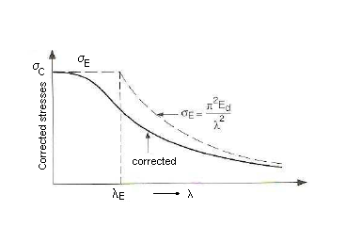 | 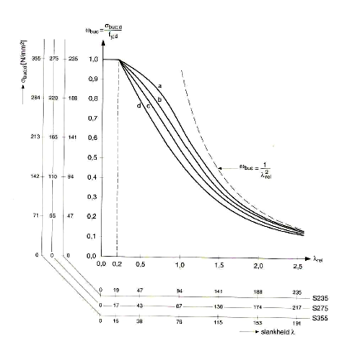
a) Reduction factor function of slenderness | b) Sectional shapes and yield material diagram for reduction factor function of slenderness
Fig. 1. Reduction factor/slenderness diagrams for ultimate load establishing.

The real ultimate stress is lower that Euler buckling stress and the equation (1) was get without consider the shape and dimensions of the section and the way of construction.
Based on buckling analysis get by well known Euler equation, the practical experiences made for different sectional shapes groups and different steels propriety four slenderness graphics results and are used in all the standards in Civil Engineering. (Figure 1a). The ultimate load is compute with the relation:
(2)
An eccentric moment to change the location of the load and the load is located in the centre of gravity of new effective section.
2. Analytical model for residual stresses consideration
General considerations:
  - The load is not in the geometrical center of the section and has variation function of initial deflection and compressed load value.
  - The maximum loads are in the middle section of the girder and are applied over the whole girder.
  - For low value loads the material are in elastic state in all the section and the classical relations can be used.
  - When the loads increases and a part of the section starts to yield the deflection increase nonlinear and we must get a new approximation for the phenomenon must be made.
  - The compression stress in the area that becomes plastic will not increase over the compression yield stress.
  - The parts of section where the stress are little that compression yields will be considered reduced cross-section or effective cross-section.
  - The effective cross-section is asymmetric and the gravity center shift with every load value.
  - Do to consideration that the stress at mid-section is extended over whole girder, the gravity center change the position in all the sections.
  - For calculation, the force is located in the gravity centre and the shift of gravity center is approximate using an added bending moment. That bending moment generate an extra deflection and the shift against the gravity center of the section.
  - The initial deflection is considerate.
If the partial yielding load on the structure is called F₁ then the total deflection of the middle section of a beam column will be:
(3)
where: is the Euler buckling load; d₁ – the total deflection at force F₁; d₀ – the initial deflection (when F = 0 N); F₁ – the partial yielding load.
Because the sine shapes of the deflection, the most critical cross-section is the middle section of the beam and the stress shape in that section is considerate to be the seam in all the beam cross sections. In reality the ends zone of the beam start to yield at larger loads that the middle zone of the beam. That assumption is made for mathematical modeling simplification. Schematically, the iterative modification of the loads and stress in the middle section of the beam used in mathematical method is presented in Figure 2.
The current analyze load case “i” dates are the loads of the previous load case and the deflection calculated in this previous load case, “i – 1”. The original deflection, d₀ appear in the first load case i = 1. The residual stress is considerate using the simplified shape repartition, given in Figure 3.

The beam deflection model consideration | Beam load and eccentricity | Notations
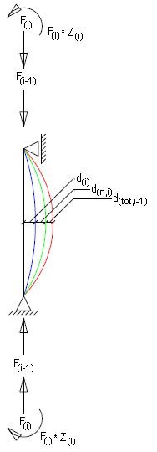 | 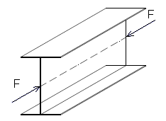 Force in the gravity sectional point | F_{(i)} = F_{(tot)}-F_{(i-1)}  F_{(i)} – the extra load of the compressed bead  d_{(tot,i)} – the total deflection at F_{(i-1)}  d_{(n,i)} – the deflection due eccentric force  d_{(i)} – the deflection due to F₁  z_{(i)} – the shift between the effective section gravity point and original gravity section point
 | 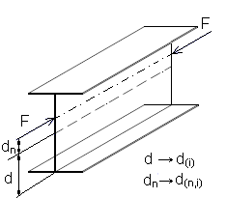 Stiffness dn of point application
 | 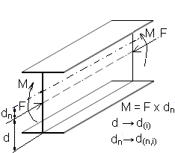 Loading force system for deflection calculation

Fig. 2. The computing scheme of the deflection of compressed beam.

Residual stress shape | Considered sections evolution under loads
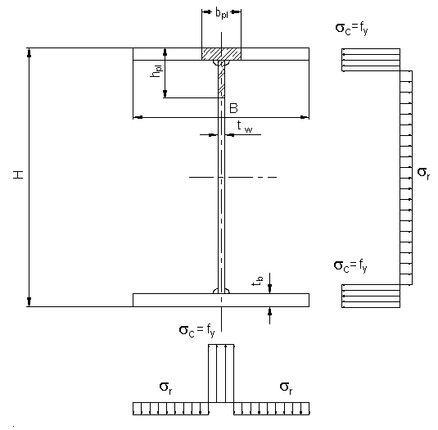 Reduced residual stress diagram
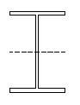 Profile without reductions (I₁,A₁) | 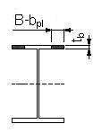 Profile with reduction on left flange (I₂,A₂)

Fig. 3. Simplified residual stress shape repartition.
Residual stress shape | Considered sections evolution under loads
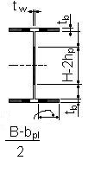 Profile with reduction on web and flanges (I₃,A₃) | 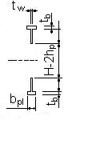 Profile with reduction on web and flange (I₄, A₄)

Fig. 3 (continued).

Analysis model. The equilibrium between the internal and external bending moments represents the condition of mathematical expression of ultimate load and deflection.
The external load bending moments are the loads multiplied by the deflection. The internal moment is the curvature multiplies by stiffness and the curvature represents the second derivative of the deflection. Solving this condition an iterative expression for current deflection, d_{(tot,i)}, is the form:
(4)
(5.1..5.4)
where: d_{tot,i} is the total deflection at load case i [mm]; d_{tot,i-1} – the total deflection at load F_{i-1} [mm]; d_{m,i} – the deflection due to bending moment in load case i [mm]; d_{i} – the extra deflection due to the difference in normal force [mm]; F_{i} – the value of load in case i [N]; F_{i-1} – the load in the in the case i-1 (N); I_{i} – the moment of inertia in case i [mm⁴]; A_{i} – the area of section in the case i [mm²]; F_{E,i} – the Euler buckling load in case i [N]; h_{i} – the difference between the original gravity point and the effective point of gravity in case i.
The initial hypotheses of the analysis are:
- There is an initial deflection;
- There is a force in the section that generate partial yielding;
- An deflection due to original load exist;
- There is an additional force;
- There is a difference between the original centre of gravity and the effective point of gravity;
3. Technological influence
on residual stress shape
The double T beams are made by rolling or welding processes and specifically residual stress values and distributions are obtained. In the case of rolling process the residual simplified stress distribution consideration is based on b_{pl} = B/2, h_{pl} = H/4 and the value of residual stress is equal with 30% of yield stress.
For joining [1-3] by welding beam realize the process was studied using diverse technology variant. Function of welding technology, the b_{pl}, h_{pl}, A_{pl} and stress shape become different. The technological analyzed calculus variant is given in figure 4.
The technological analyzed variants are given in the Table 1.
Physical material properties are presented in table 2.
Correction with the number of layers and mode of layers deposits was made helped by the statistical relations:
● Symmetric welded deposit Asymmetric weld deposit:
(6.1)
(6.2)

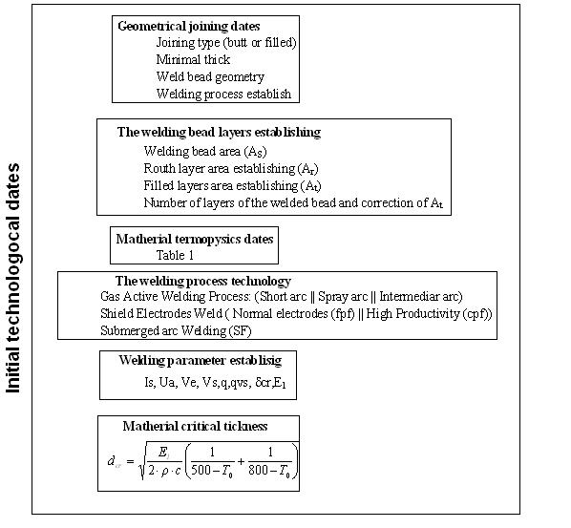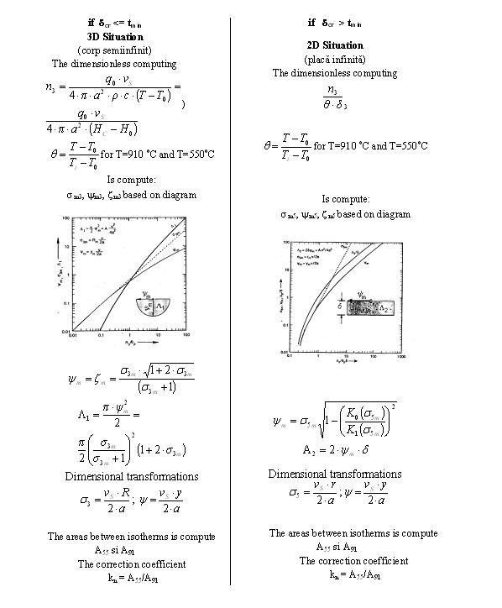

Fig. 4. The schematics area plasticity establishing.

Table 1
The technological analyzed variants
Asymmetrical welds variants
V1 | V2 | V3
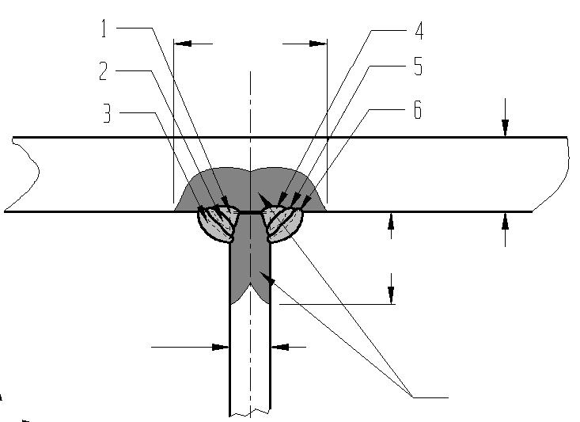 | 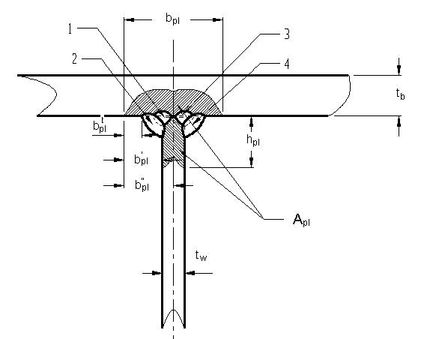 | 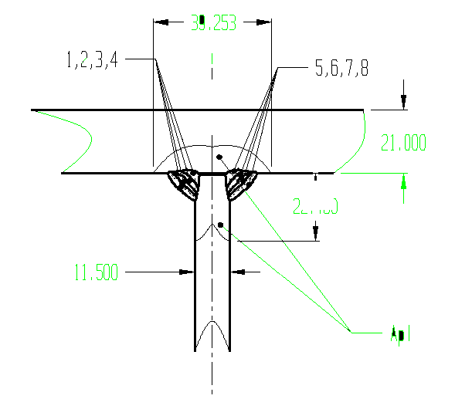
Symmetrical welding variants
V1 | V2 | V3
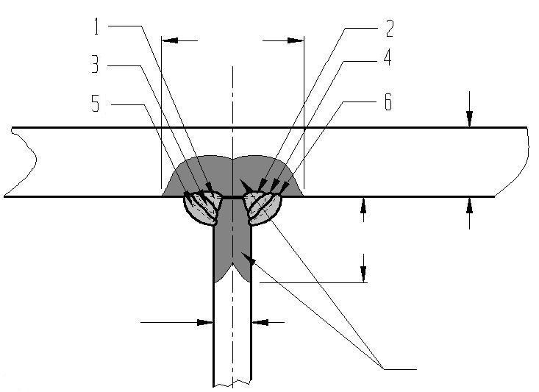 | 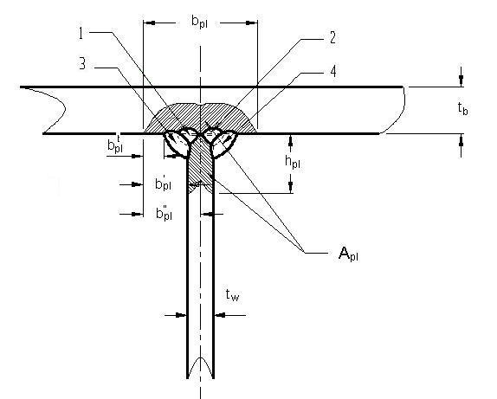

Table 2
Physical properties of considerated steels
Symbol | Name | Low alloyed steel | Mesure unit used
λ | Thermal conductibility | 0,025 | W/(mm·ºC)
a | Thermal difuzibility | 5,0 | mm²/s
ρ·c |  | 0,005 | J/(mm³·ºC)
T_{t} | Fusion temperature | 1520 | ºC
H_{m} – H₀ | Solid phase enthalpy | 7,5 | J/mm³
ΔH_{m} | Melting heat | 2,0 | J/mm³

● Establishing the residual stress for welded variants
(7)
(8)
(9)
(10)
where: E_{l}^{e} is the linear energy of welding; t_{w} – dimens. of web plate; t_{b} – dimens. of flage plate; A_{pl}^{A} – plastical area corrected; A – sectional area; z – joined parts (assemble) weight center position; z_{S} – distance between welded area weight center point and the assemble section weight center; ε_{c} – strains of the yield stress; μ – material coefficient; α – thermical volumical contraction; c – speciffical haet of material; ρ – material density; k_{c} – correction coefficient
The plastically area is evaluate in this paper with the formule:
(11)
where: A_{pl} is the the matherials area inclosed in inside the isotherma T=550 ºC for the bass matherial; ψ_{m55r} – the width of the isotherma T = 550 ºC calculate for ruth layers; ψ_{m55t} – the width of the isothermals T = 550 ºC calculate for the deposits layers; n_{t} – the number of layers; k_{a} – the correction coefficient function of welding technology.
For the welded girders double T welded in the best conditions of assembly with all the parts clamped and using the same technology for the flanges and web welding, the methods for stress diagram estimation is based on the equations:
(12)
(13)
In the considered case:
(14)
And final expression for the welding process becomes:
(15)
Welding process was Gas Active Metal Arc Welding (GAMAW) with short arc variant and electrode wire diameter 1.2 mm. The geometrical parameters established were given in table 3.
The isothermals geometrical characteristics and uncorrected plastically area resulted are give in Table 5.
The compression stress results in the middle section of the double T girder are presented in Table 7.

Table 3
Technological characteristics of layer
Geometrical parameters | Root Area,  A_{r} [mm²] | Filled layers area,  A_{t} [mm²] | Number of layer,  n | Welding area,  A_{s} [mm²]
Variant 1 | 18 | 30 | r+2t | 78
Variant 2 | 25 | 45 | r+t | 70
Variant 3 | 18 | 20 | r+3t | 78
Table 4
The welding principal’s parameters for considerate technology
 | I_{s}  [A] | U_{a}  [V] | V_{e}  [cm/min] | V_{s}  [cm/min] |  | E_{l}  [kJ/cm] |  | δ_{cr}  [mm]
 |  |  |  | r | t | r | t
Variant 1 |  |  |  | 12,323 | 7,394 | 8,028 | 13,38 | 17,5
Variant 2 | 118 | 14 | 196,33 | 8,873 | 4,929 | 11,5 | 20,69 | 22,54
Variant 3 |  |  |  | 12,323 | 11,091 | 8,028 | 8,92 | 18,43

Table 5
The isothermal characteristics considerate for one joint
Isothermal principal caracteristics |  |  |  |  |  |  |  | A_{p}  [mm²]
 |  | T_{t} = 1520 ºC |  | T_{AC3} = 910 ºC |  | T_{pl} = 550 ºC |  | A_{p}  [mm²]
 |  | b_{m}  [mm] | A_{m}  [mm²] | b_{m91}  [mm] | A_{m91}  [mm²] | b_{m55}  [mm] | A_{m55}  [mm²] | A_{p}  [mm²]
V1 | r | 3,295 | 17,06 | 4,691 | 34,56 | 6,5 | 66,516 | 247,696
V1 | t | 4,096 | 26,35 | 5,746 | 51.853 | 7,594 | 90,64 | 247,696
V2 | r | 4,57 | 32,907 | 6,515 | 66.7 | 9,038 | 128,31 | 368,966
V2 | t | 6,543 | 67,64 | 9,093 | 129,9 | 12,378 | 240,656 | 368,966
V3 | r | 3,295 | 17,06 | 4,691 | 34,56 | 6,5 | 66,516 | 276,93
V3 | t | 4,603 | 33,279 | 4,824 | 36,556 | 6,682 | 70,139 | 276,93

Table 6
The resulting parameters for plasticity area for flange-web welding
 | A_{I} = 2*A_{S} [mm²] | Condition t_{w}* [mm] | k_{m} | K_{b1}^{S} | K_{b1}^{A} | A_{pl55} [mm²] | A_{pl}^{S} [mm²] | A_{pl}^{A} [mm²]
V1 | 156 | 80,19 | 0,458 | 0,498 | 0,793 | 495,392 | 246,625 | 392,646
V2 | 140 | 95,983 | 0,611 | 0,655 | 0,978 | 737,932 | 483,542 | 770,425
V3 | 156 | 65.8 | 0,3737 | 0,413 | 0,598 | 553,86 | 228,828 | 363,94

Table 7
The residual estimation stress and strains
Technological versions |  | A_{pl} [mm²] | b_{pl} [mm] | h_{pl} [mm] | E_{l}^{e} [kJ/cm] | σ_{Z}^{A} [daN/cm²] | d₀ [mm]
Asymmetric | V1 | 392,646 | 14,678 | 7,339 | 5,373 | -106,9 | L/1000
Asymmetric | V2 | 770,425 | 28,808 | 16,4 | 11,07 | -220,2 | L/1000
Asymmetric | V3 | 363,94 | 13,605 | 6,803 | 4,963 | -98,725 | L/1000
Symmetric | V1 | 246,625 | 9,22 | 4,61 | 3,314 | -65,954 | L/1000
Symmetric | V2 | 483,542 | 18,08 | 9,04 | 6,694 | -133,193 | L/1000
Symmetric | V3 | 228,828 | 8,55 | 4,28 | 3,069 | -61,061 | L/1000

4. Model results
The ultimate weld technology consist in the estimation of plasticity area extended over all the section of flanges and web and give an extremely extended plastically area. In reality the correctionless coefficients with technological parameter give more extended deflections that were established in reality. These cases are used for most badly residual stress reduced diagram. The results in this case are done in the Table 8.
The program for welded technology, accordingly with Figure 4 for Gas Active Arc Welding for d_{e} = = 1.2 mm diameter with welding parameters accordingly with tables 2,6 and the buckling estimation of the girder column accordingly with Figure 2 and 3 was made in Visual C/C++. The diagrams for Critical Buckling Force and Column Length and the Buckling Curves for the all the welding technology considerate are give in the figure 5 and Figure 6 respectively for diverse column length [9]. We try to get good predictions for Columns length between 1 and 50 m and to verify the results using the diverse usual national and international design curves standards. The results were verified using the FEM method too for diverse Columns length and in von Mises [8], [5] isotropic plasticity model using the COSMOS software. For the case of a Column with 10 m length and in the hypothesis of 10 mm initial displacement the results are give in Table 10 figures.

Table 8
The technological variants and the corrected
plasticity area (ec. 11)
 | A_{I}=2*A_{S}  [mm²] | Condition  t_{w}* [mm] | k_{m} | K_{b1}^{S} | K_{b1}^{A} | A_{pl}  [mm²] | A_{pl}^{S}  [mm²] | A_{pl}^{A}  [mm²]
V1 | 156 | 80,19 | 0,458 | 0,498 | 0,793 | 945 | 436,5 | 749,39
V2 | 140 | 95,983 | 0,611 | 0,655 | 0,978 | 1126,6 | 739,92 | 1101,48
V3 | 156 | 65.8 | 0,3737 | 0,413 | 0,598 | 845,32 | 364,33 | 505,5

The compression values of stress and deflection, d₀.
Technological variants |  | A_{pl} [mm2] | b_{pl} [mm] | h_{pl} [mm] | σ_{Z}^{A} [daN/cm²]
Asymmetric | V1 | 392,646 | 44,953 | 27,339 | -306,9
Asymmetric | V2 | 770,425 | 54,95 | 26,4 | -520,2
Asymmetric | V3 | 363,94 | 41,23 | 26,803 | -287,725
Symmetric | V1 | 392,646 | 34,953 | 17,339 | -236,3
Symmetric | V2 | 770,425 | 44,95 | 26,4 | -412,2
Symmetric | V3 | 363,94 | 32,3 | 23,803 | -248,23

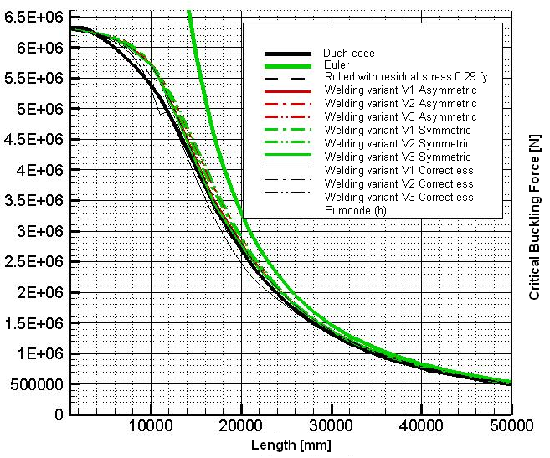

Fig. 5. Critical Buckling Force resulted for diverse length
and welding technologies.

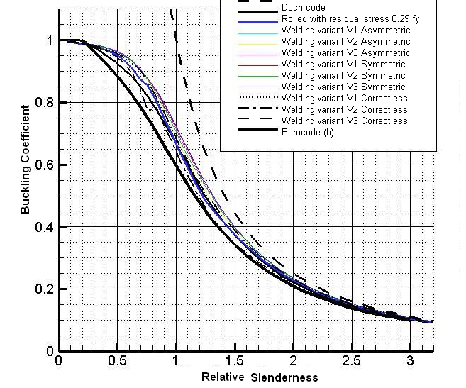

Fig. 6. The Buckling Curve Factor function of the relative
slenderness for diverse welding technologies.

Table 10
Results of a column with 10000 mm length for stress and sistortions.
The analyse was made using symmetry loading and sectional geometry
Time force analyse modelling | Time deformation variation
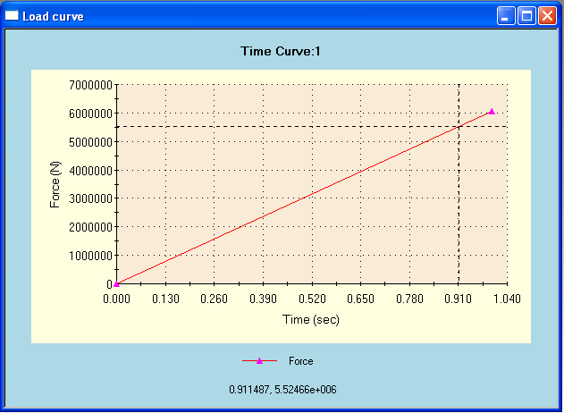 | 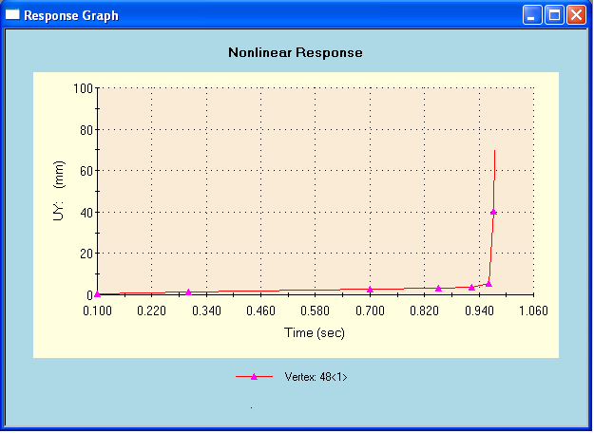
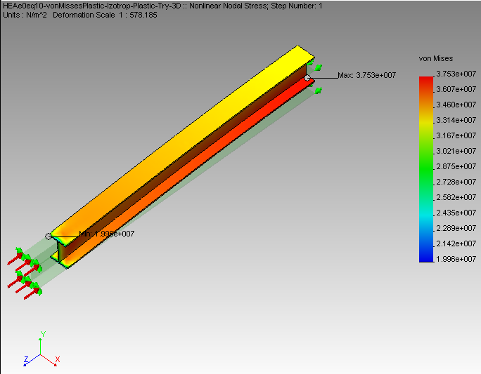 | 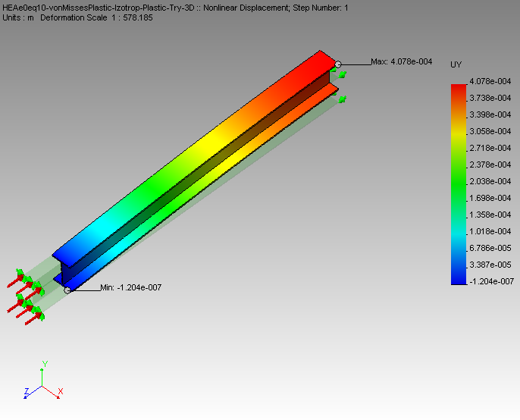
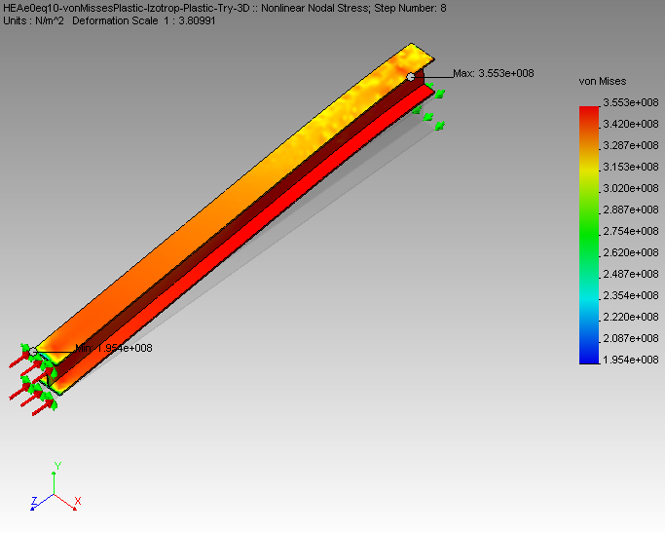 | 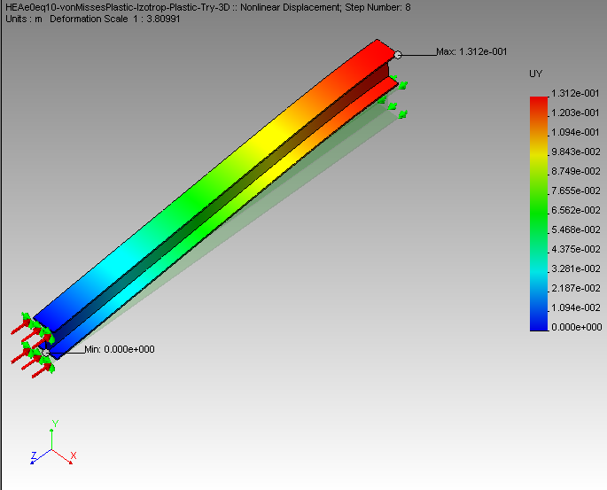
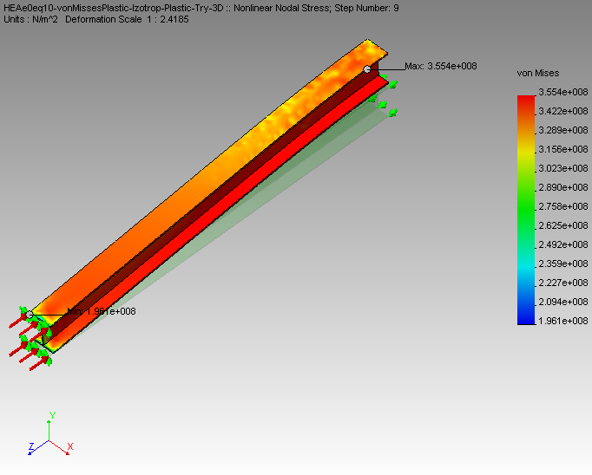 | 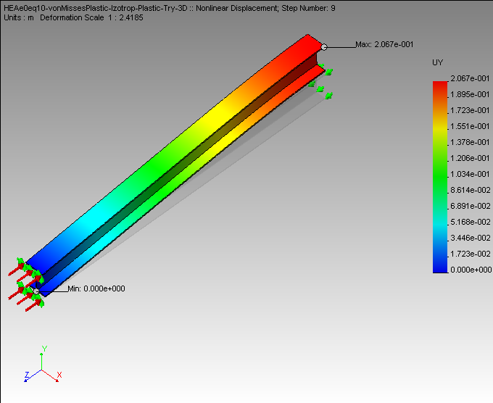
Table 10 (continued)
Time force analyse modelling | Time deformation variation
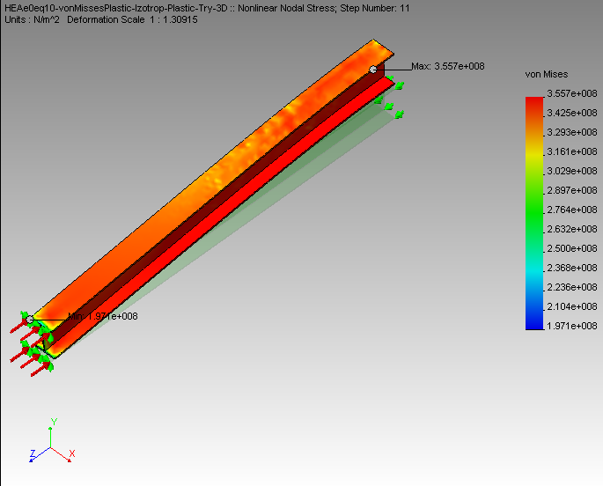 | 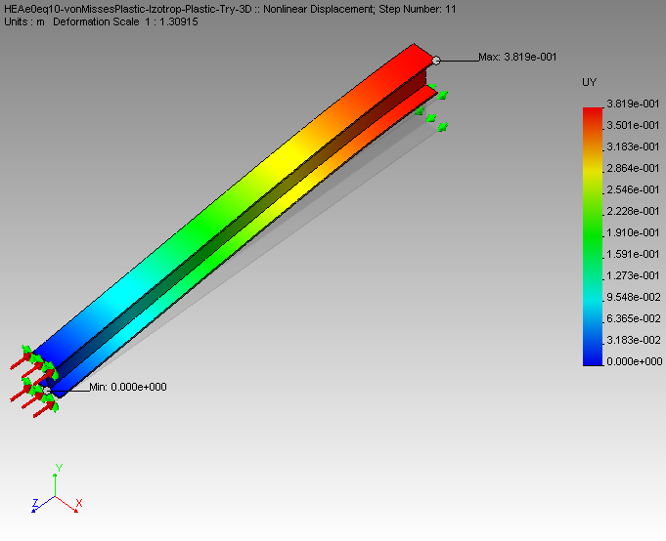
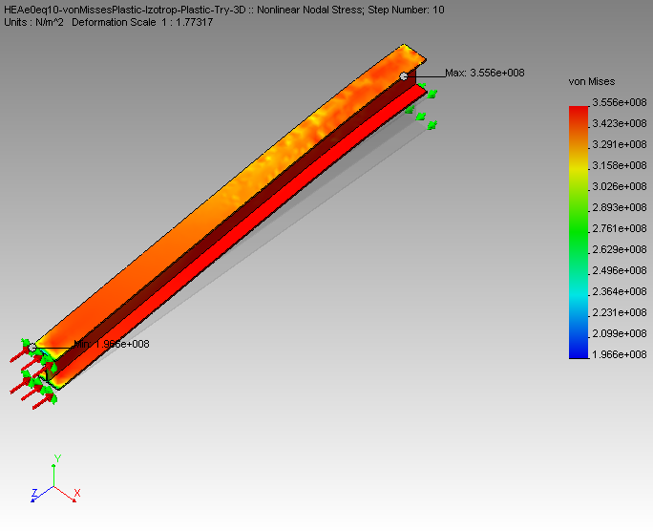 | 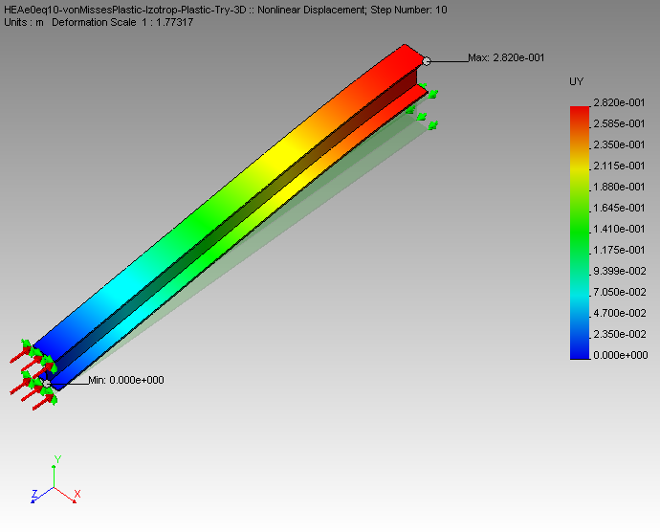
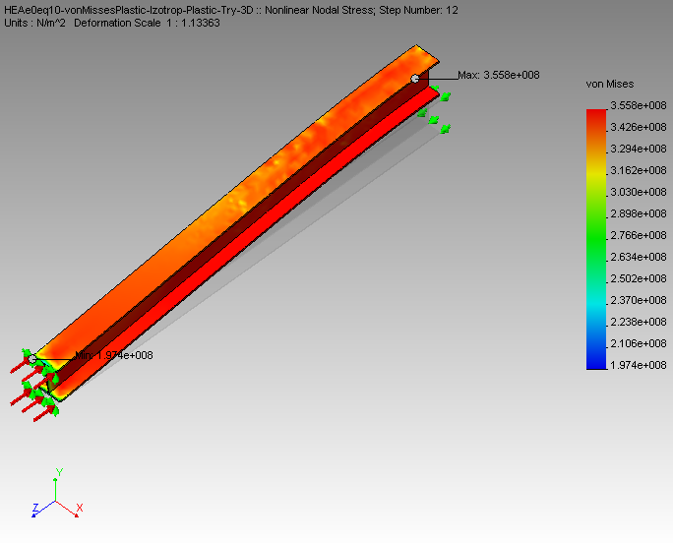 | 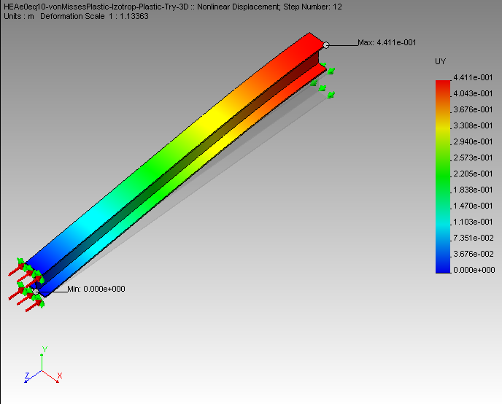

5. Conclusions
- The own model, based on analytical modelling of Columns instability give a good approximations for critical loads and buckling curves for high length of double T articulated girder.
- The proposed model results, for all the area of length analyzed and for the residual welding stress estimation are in the area of viability conforming the European Codes of design for all the possible welding technologies. Even without the corrections estimations for plastically area induced by welding.
- The reserves of critical loads in the case of the best welding technology become too large even if the residual deflection (d₀) is L/1000 accordingly with the maxim accepted deflection in the design codes.
- The DIN, Dutch, Romanian and other national Design codes give highest critical loads that Euro codes and their value are in according with the residual stresses and deflections that are obtained in the case when the welding technology is used in accord with the national welding technological process standards.
- The welding residual stress and distortions estimations conduce to establish a technology that can decrease the weight of the structure. In the case of tall buildings, the method can give appreciable economy in steel and welding materials.
- The computing time in the case of proposed method is less that the FEM method and the program made in Microsoft Visual C/C++ get output for Tecplot postprocessor product. In this case the graphical possibilities of our program increase and the results can be easy integrated in the design processes of the structure.
Bibliography
- Grong, O., Metallurgical Modelling of Welding. Second Edition. The University Press Cambridge, 1995.
- Matsuda, F., Liu W., Sh., Cooling time parameter and hardenability estimation of haz in welding of medium, high carbon machine structural steels. Mathematical Modelling of Welding Phenomena. Vol II. The Institute of Materials, 1995.
- Goldak, J., Gu, M., Computational Weld mechanics of the Steady State. Mathematical Modelling of Welding Phenomena. Vol II. The Institute of Materials, 1995
- Gioncu, V., Ivan, M., Teoria comportarii critice si post critice a structurilor. Ed. Academiei, 1974 Bucuresti., pp. 145-147.
[5] Collantes B., Gomez R., Identification and modelling of a three phase arc furnace for voltage disturbance simulation, IEEE Transactions on Power Delivery, Oct. 1997, Volume: 12, Issue: 4, pp. 1812-1817.
[6] cert.obninsk.ru/gost/785/785.html
[7] www.bikudo.com/product_search/details/71255/m
[8] wendt.library.wisc.edu/miles/milesbook.html
[9] *** SR – EN – 1993 ** 2007. Metal design Euro Codes.

About the authors
Lecturer . Eng. Ioan-Sorin LEOVEANU, PhD
University “Transilvania” from Braşov
email:cucus@bravt.com

Mechanical Engineer of the University Transilvania from Brasov, the Managerial Industrial Program with Welding Especiality and PhD in residual stresses and strains modelling and technology optimisation. He worked at the Industrial Tractors Design and Research Institute at ICPATT Brasov to havy and mediun Bulldozers prototips design and other Earth Moving Machineries prototipes and series products. From 1988 he work at Transilvania University at Materials Science and Engineering Faculty and from 2010 he work in the area of Civile Engineering at Transilvania University. He publish monographis in the area of Optimization Technology and Transport. (Maximum 6 rânduri)

Assoc. Prof. Eng. Eva Kormaníková, PhD.
Technical University of Košice, Civil Engineering faculty, Institute of Structural Engineering, Department of Structural Mechanics, Vysokoškolská 4, 040 01 Košice, Slovakia.
email:cucus@bravt.com

Graduated at the Technical University of Košice, Civil Engineering Faculty, study program - Building Construction. After finishing of the university she started to work at the Technical University of Košice, Civil Engineering Faculty, Department of Structural Mechanics as assistant. PhD. graduated at the Technical University of Košice, Faculty of Mechanical Engineering, study program – Applied Mechanics. Since 2009 she has worked at Civil Engineering Faculty TUKE, study program – Theory and Design of Engineering Structures, as associate professor. Her research topic is design and optimization of structural elements and structures made. (Maximum 6 rânduri)

Assis. Eng. Kamila Kotrasová, PhD. ,
Technical University of Košice, Civil Engineering faculty, Institute of Structural Engineering, Department of Structural Mechanics, Vysokoškolská 4, 040 01 Košice, Slovakia.
email:cucus@bravt.com

Graduated at the Technical University of Košice, Civil Engineering Faculty, study program - Building Construction. After finishing of the university she started to work at RCB in Spišská Nová Ves as designer and then at the Technical Technical University of Košice, Faculty of Mechanical Engineering, study program – Applied Mechanics. The research topics: seismic design of liquid storage ground-supported tanks, interaction problems of fluid and solid. (Maximum 6 rânduri)

Assis. Eng. Daniel TAUS,
University “Transilvania” from Braşov
email:cucus@bravt.com

Graduate of the Civil Engineering Faculty of “Transilvania“ University. After finishing University he started to work in the metal structure design at CI-Bv Faculty. The research topics in steel design of industrial structures and welding.
(Maximum 6 rânduri)

