Dear Partners,

We have the pleasure to present you Conacul Domnesc Suceava.

CONACUL DOMNESC from Suceava is a quiet complex ideally situated in the middle of a 13 hectare park, and it is perfect for a relaxing break from the hectic life in the city.

Hotel :
The hotel has 40 rooms with 80 beds capacity.
The hotel also offers a junior suite and a suite.
For those who enjoy walking, venture down, our illuminated scenic path to arrive to our very own lake.

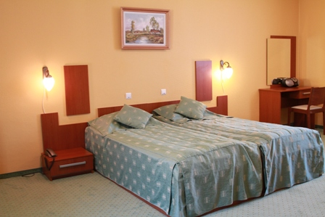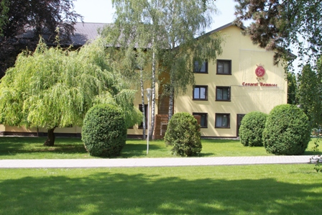

Restaurant :
Our restaurant seats 180 people and in the evenings we invite you to relax and enjoy our vast selection of wines in an intimate and old fashion atmosphere.
We also offer a large outdoor terrace and garden bar facing the park, were childrens can play safely.

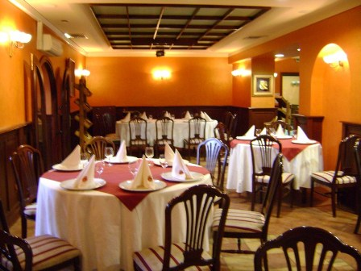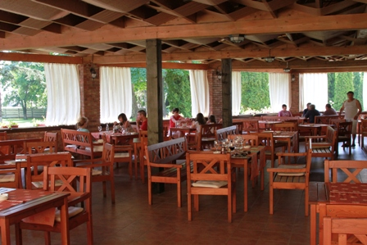
Restaurant Terrace

Conference halls:
Conacul Domnesc also provides a sport hall in which we can organize the largest events in town, with over 500 seats.
Together with our 45 x 36 meters open air tennis court and football pitch with synthetic grass we offer a chance to get fit and relax in the same time.

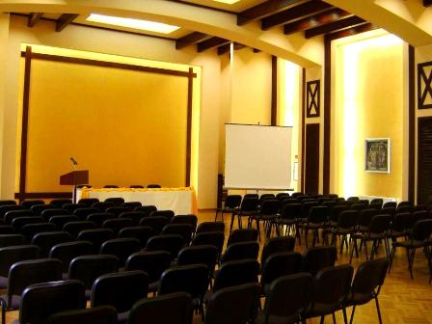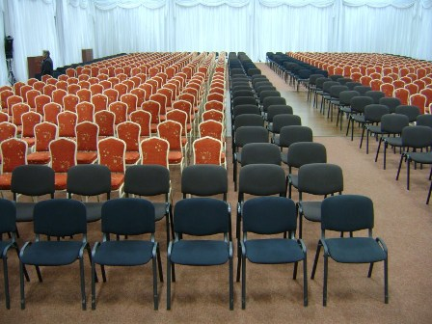
Amfiteatru Hall Polivalenta Hall

Centrul SPA :
Conacul Domnesc offers one of the largest leisure facilities in Suceava.
Our SPA center provides in door swimming pool 17 x 8 meters, Jacuzzi, four saunas body treatments, a special area for massage, and a modern fitness center.
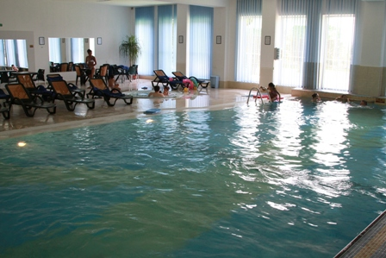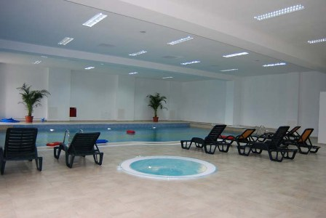
SPA

For special offers, do not hesitate to contact us :
CONACUL DOMNESC
Str. Agronomului, nr. 445, Suceava
Tel : 0040/230/526 966, fax :0040/230/520 699
E-mail : loredana.protiencu@conaculdomensc.ro

Regards,
Loredana Protiencu
Marketing Manager – 0040 730 022 444

